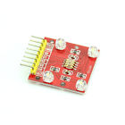**Color TCS230 TCS3200 Recognition Sensor Detector Module Color Sensor For Arduino**

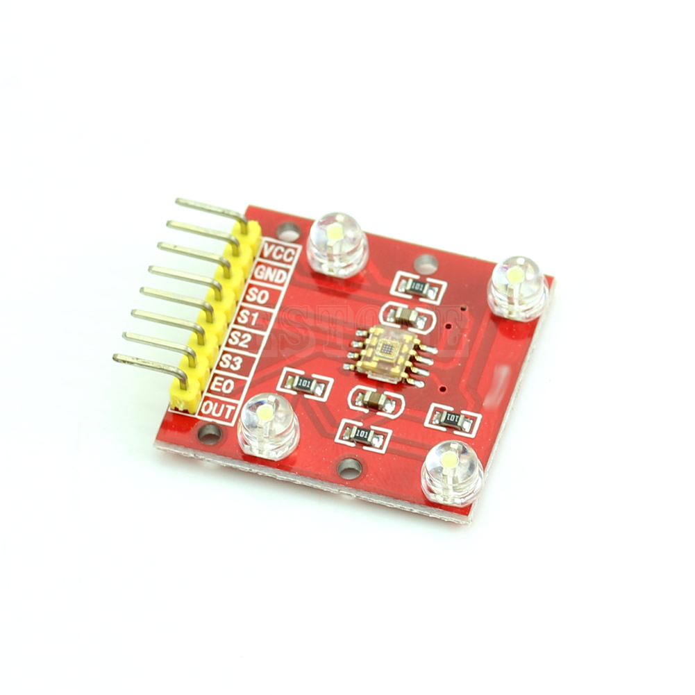

* **100% brand new and high quality**
* Board size: 2.9CM*2.7CM ( length and width)
* VCC GND power supply interface definition
* SO-S3 E0 OUT communication interface
* Onboard TCS3200 color sensor;
* Support for 3V-5V input voltage;
* Chip pins have all led to the standard 100mil, pin ( 2.54mm ), convenient for lattice board;
* The module test of various colors exist a certain color, the color test demanding person please consider carefully before purchase.
* TCS3200 and to test the object optimal distance of approximately 1cm

**Design background**

* With the speed of modern industrial production , development of automation direction , the production process has long played a leading role by the human eye color identification work will increasingly be replaced by the corresponding color sensor. For example: library use color-coded classification of the literature , can greatly improve the management and statistical bent , etc. ; in the packaging industry , packaging produced using different colors and decorated to represent their different nature or purpose. The color sensors are usually present on a separate cover photodiode corrected red, green, and blue filters , and the processing of the output signal corresponding to the color signal identified ; some will be set up between the two , but the output analog signals, the one A / D acquisition circuitry , the signal is further processed to identify and increase the complexity of the circuit, and there is a large identification error , affecting the recognition results. TAOS (TexasAdvancedOptoelectronicSolutions) 's new color sensor TCS3200, not only to achieve recognition and detection of color , compared with the previous color sensor , but also has many excellent new features.

**TCS3200 chip introduced**

* TCS3200 is TAOS company launched a programmable color light-to- frequency converter , which the configurable silicon photodiodes and a current -frequency converter integrated on a single CMOS circuits on a single chip while the red-green- blue (RGB ) three filter is compatible with the industry's first digital RGB color sensor interface , the output signal TCS3200 is digital, you can drive a standard TTL or CMOS logic input , so you can directly with a microprocessor or other logic circuits connected , since the output is digital, and the conversion accuracy can be achieved for each color channel than 10 , thus eliminating the need a / D conversion circuit, the circuit becomes easier.
* TCS3200 8- pin SOIC surface mount package , integrated on a single chip has 64 photodiodes , these diodes are divided into four types , which 16 of the photodiode with a red filter ; 16 photodiodes with a green filter ; photodiode 16 with a blue filter , and the remaining 16 without any filter can, through all of the light information in the photodiode chip is arranged in a cross , it is possible to minimize the incident light uniform radiation , thereby increasing the accuracy of color identification ; other hand, the same color of the photodiode 16 is connected in parallel , uniformly distributed in the diode array, the position error can be eliminated color. When working through two programmable pins to dynamically select the desired filter , the typical range of the sensor output frequency from 2Hz-500kHz, users can also choose two programmable pins to 100% , 20% or 2% output scale factor , or power-off mode. The output scale factor so that the output of the sensor can be adapted to different measurement ranges , improved its ability to adapt . For example , when using low frequency counters can select a small scaling value so that the output frequency and the counter TCS3200 match .
* When the incident light is projected onto the TCS3200 on , the control pin photodiode S2, S3 different combinations , you can choose different filters ; through the current to frequency converter after the output of different frequency square wave ( 50% duty cycle ) different colors and light intensity corresponding to different frequency square wave ; may also be controlled by scaling the output pins S0, S1, choose different output scale factor , the output frequency range to be adjusted to suit different needs.
* Brief TCS3200 chip function of each pin and it 's some combination of the following options . S0, S1 is used to select the output scale factor or power shutdown mode ; S2, S3 is used to select the type of filter ; OE anti- frequency output enable pin , you can control the output of the state, when there are multiple chips are pin-shared when the microprocessor output pin can be used as a chip select signal , OUT is the frequency output pin , GND is the ground pin chip , VCC operating voltage for the chip , table 1 S0, S1 and S2, S3 available combinations.

**Principle TCS3200 color recognition**

* Induction principle
* ( 1 ) primary colors
* Color of objects commonly seen actually irradiated to the surface of the absorbent body at its white ( daylight ) in the colored component part and another part of the colored light reflected off the eyes of the reaction . White is a mixture of various frequencies together to form visible , that contains a variety of colors white shade ( such as red R, Huang Y, green G, blue V, blue B, purple P). According to the German physicist Helmholtz (Helinholtz) theory shows that the three primary colors , a variety of colors by mixing different proportions of the three primary colors ( red, green , blue ) formed .
* (2) TCS3200 color recognition principle
* Induction principle known by the three primary colors , if you know the value of the three primary colors constitute a variety of colors , we can know the color of the object being tested . For TCS3200 , when selecting a color filter , it only allows a particular primary color by preventing other primaries through . For example : When the red filter , the incident can be only red , blue and green are blocked , so that you can get the light intensity red light ; while selecting the other filters , you can get a blue light and green the intensity of the light. These three values can be analyzed to the color of the light projected on the sensor TCS3200 .
* ( 3 ) white balance and color recognition principle
* White balance is to tell the system what is white. Theoretically, white is a mixture of equal amounts of red, green and blue made ; actually white is not exactly equal to the three primary colors , and an optical sensor for TCS3200 , it these three basic is not the same color sensitivity , resulting RGB output TCS3200 not equal, so the white balance adjustment must be carried out before the test , so that the detected TCS3200 "white " in the three primary colors are equal. White balance adjustment is to prepare for the subsequent color recognition . In this apparatus, the white balance adjustment method and specific steps are as follows : the empty tubes placed above the sensor tube is placed above a white light source , the incident light can pass through the tube is irradiated to a TCS3200; previously described under the method of sequentially gated red, green and blue filters , respectively, the measured red, green and blue values , then we can calculate the required three adjustment parameters.
* When TCS3200 identify the color , use these three parameters to the measured colors R, G and B adjust. There are two ways to calculate the adjustment parameters: 1 , followed by gating three color filters , and then turn on the TCS3200 output pulses are counted . 255 to stop the count when the count , were calculated for each channel used in time, which corresponds to the actual test time reference used TCS3200 each filter , the number of pulses during this time is measured by the corresponding R, G , and B values . 2 , the timer is set to a fixed time ( e.g. 10ms), and three color filters strobe , the calculation of the period of output pulses TCS3200 calculate a scaling factor , the scaling factor by the number of these pulses can be becomes 255. In the actual test , the same time the outdoor counts the number of pulses multiplied by the measured scale factor determined , then the value corresponding to the obtained R, G , and B .
* 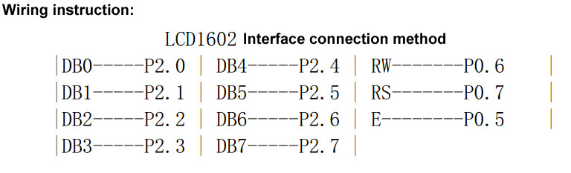
* 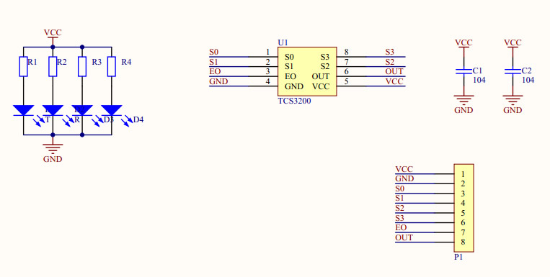

**Package includes:**

* **LM393 Single Axis Tilt Sensor SCA60C Tilt Detection Sensor Module x 1PC**

More Information:

<http://www.toptechboy.com/arduino/lesson-15-super-cool-arduino-color-sensor-project/>

<http://howtomechatronics.com/tutorials/arduino/arduino-color-sensing-tutorial-tcs230-tcs3200-color-sensor/>